Develop a Bootstrap Based Card Builder

**Objective: It will be a tool to prepare a Bootstrap Card using JavaScript.**

**Your UI will be look like this –**

**Initial Output Area**

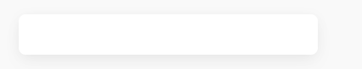

**Initial HTML Source Code**

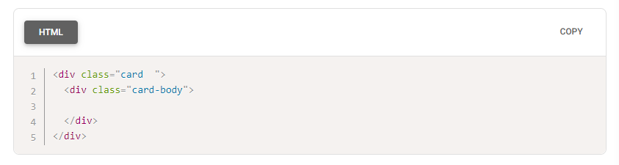

**ToolBar**

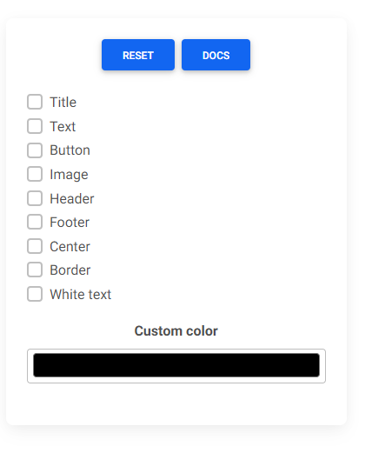

**Now When You click on checkbox of Title on Toolbar the output will be like this**

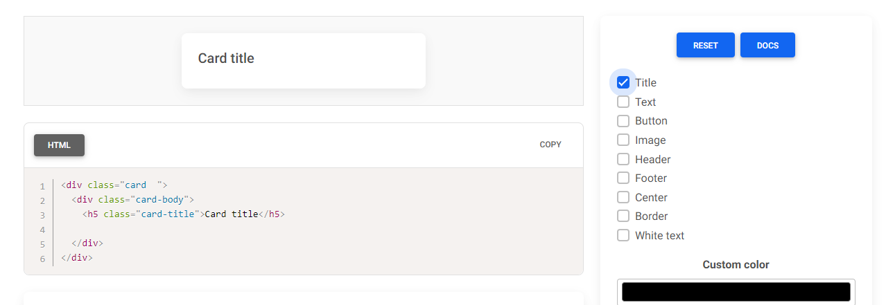

**Output Area and HTML will automatically be updated using JavaScript**

**Now see what will happen when you click on Text**

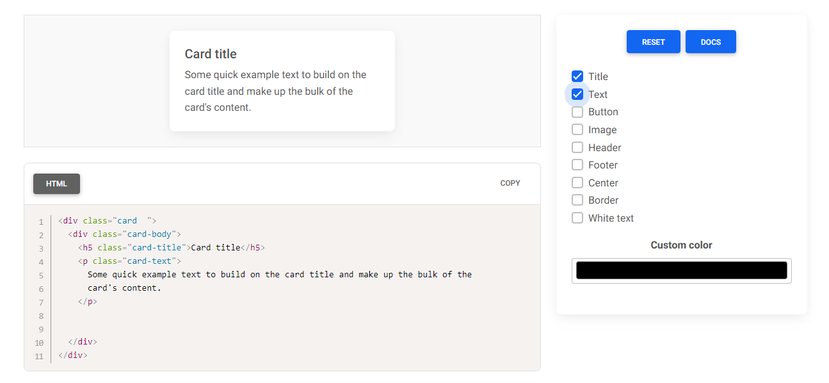

**And You click on Button**

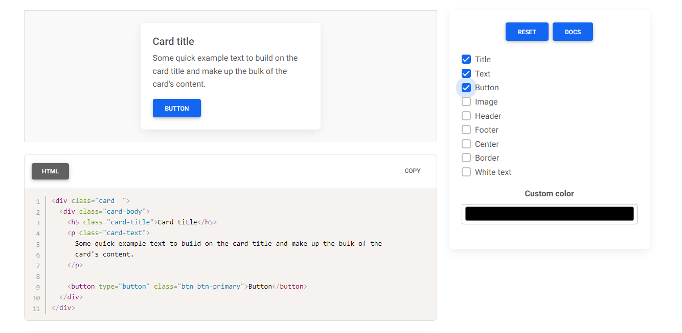

**Now if you de-select Text the output will be like this**

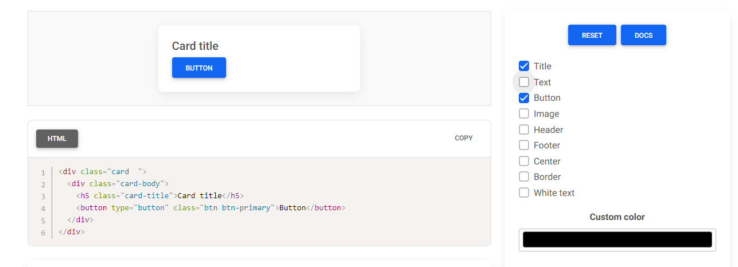

**Get the live experience from here**

[**https://mdbootstrap.com/docs/standard/tools/builders/cards/**](https://mdbootstrap.com/docs/standard/tools/builders/cards/)

**Expectation from you**

1. **Use of Only Vanilla JavaScript for the features expected**
2. **Work on BS5**
3. **Implement all the features as shown on the pictures**
4. **Add atleast one new feature on whatever you think to enrich the tool. An idea is given. It is not mandatory to follow this. You can come out with your5 own idea**

